ABOUT THE ARTIST :
SHELLEY HOWARD

Originally from Ohio, Shelley received a BFA in painting and drawing from Bowling Green State University in Ohio and an MA in visual arts education from the University of Northern Colorado, Greeley Colorado. After a long career as a Colorado art educator with related leadership positions, Shelley is happy to be making her own artistic vision a priority. She currently resides in Denver, Colorado where she maintains a studio and showroom in the Santa Fe Arts District at Artists on Santa Fe, 747 Santa Fe Drive, Denver.

Having always been inspired by the landscape especially in Colorado and New Mexico Shelley tries to infuse a sense of movement into them. The interplay between man made objects or architecture balanced with the random forms of nature allow a connection to be drawn with the medium in a very intuitive and spontaneous manner. The use of mark making in pastels or brush strokes in wet media serve as the vehicle for unifying the works. Shelley's award winning paintings and pastels are in collections in Arizona, Colorado, New Mexico, Ohio, and Texas. She is a member of the Plein Air Painters of New Mexico, the Plein Air Artists of Colorado, the Pastel Society of New Mexico, and a Signature member of the Pastel Society of Colorado.

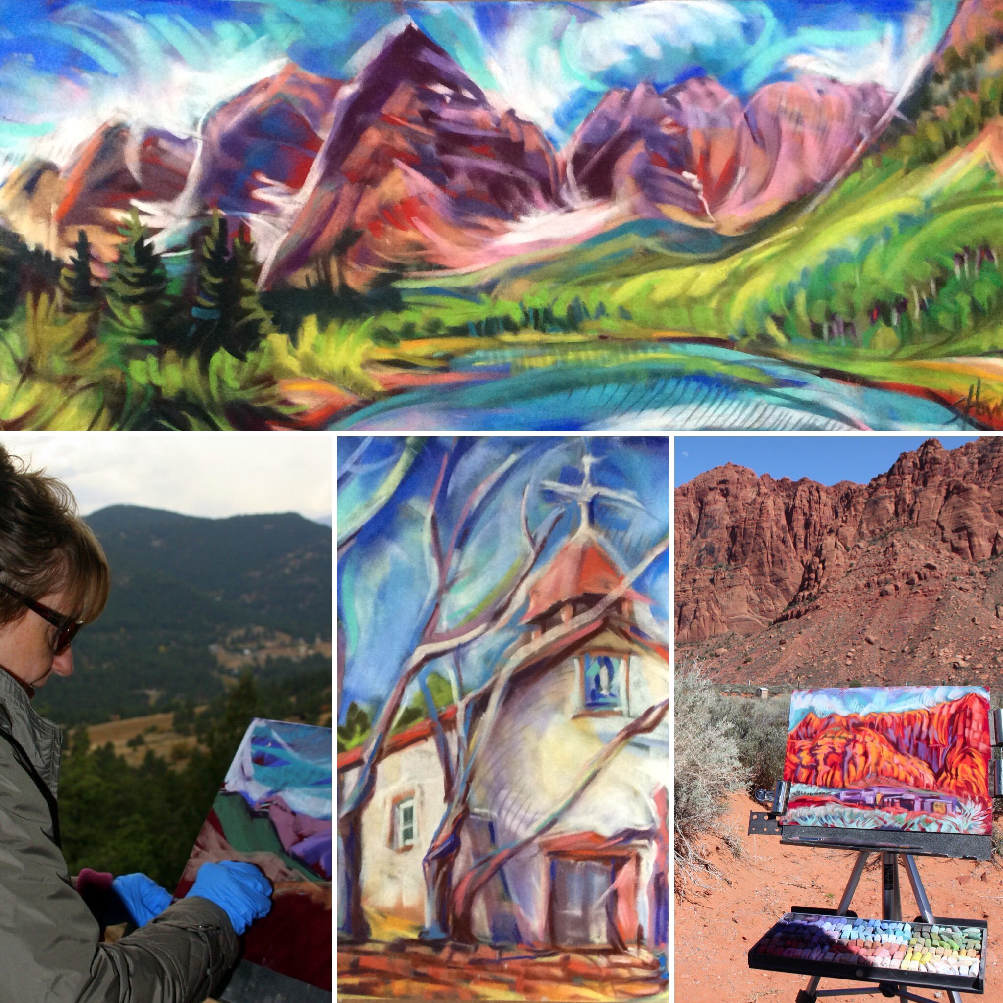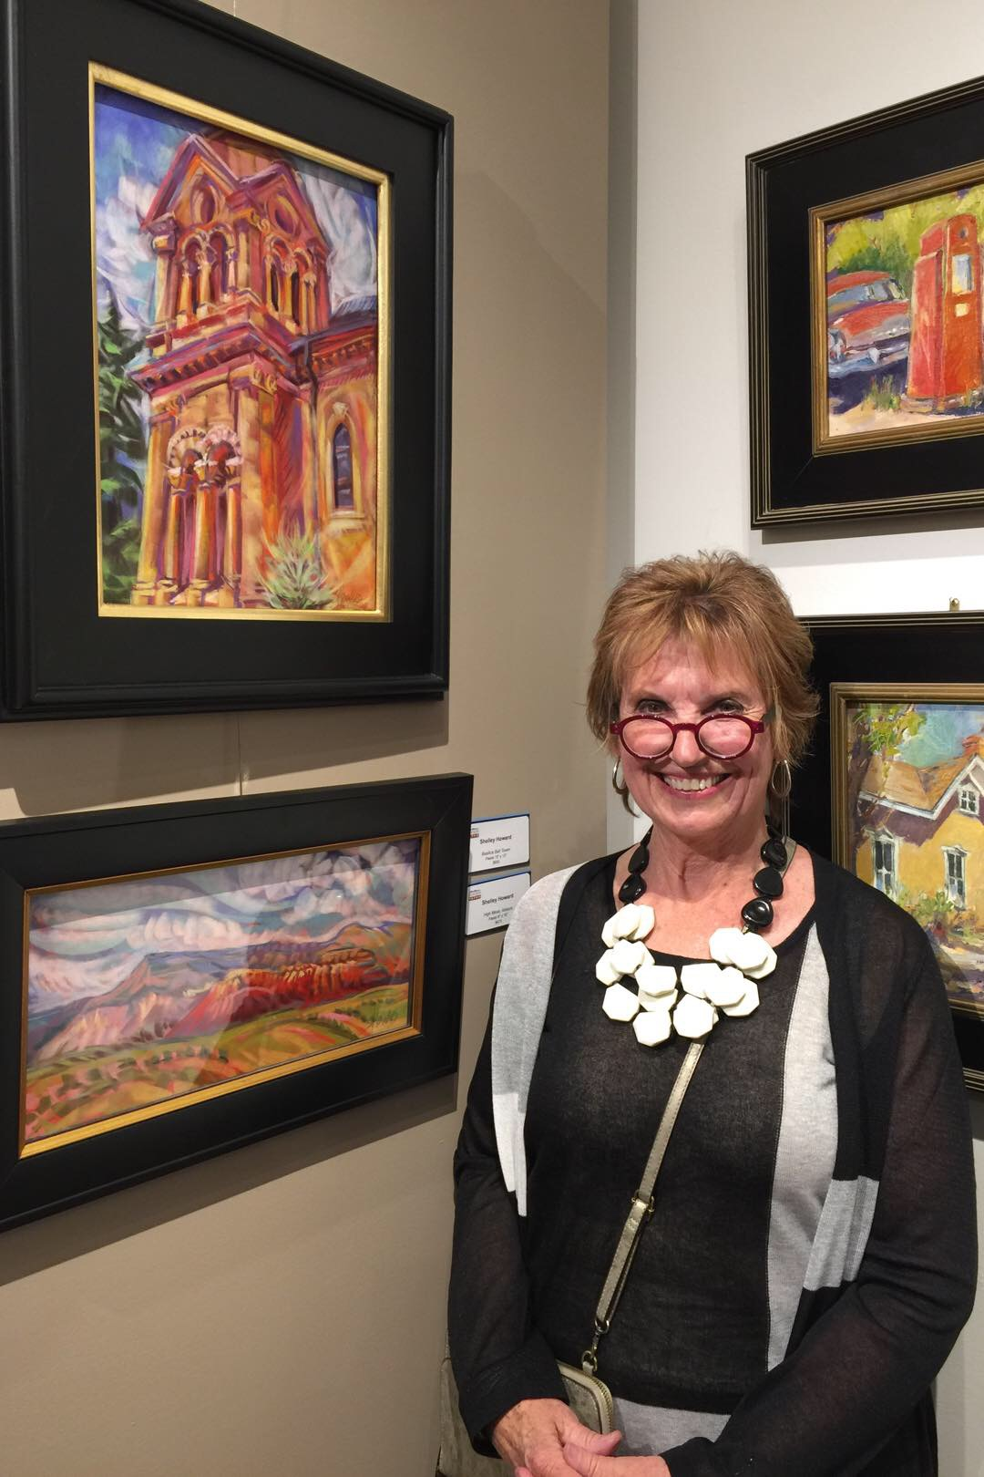

More information can be found at www.artistshelleyhoward.com.

