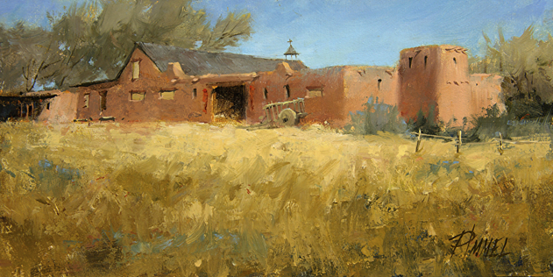

PEGGY IMMEL

START TO FINISH: CREATING SUCCESSFUL LANDSCAPES

WHEN: June 21 - 23, 2024
WHERE: Award Winning Artist Workshops, Charlotte, North Carolina
FOR MORE INFO: Shirley Harris at Award Winning Artist Workshops
CALL: (704) 607-6046 OR EMAIL: 4shirleyart@gmail.com
WEBSITE: https://www.awardwinningartistworkshops.com/workshop/35413/peggy-immel-from-nmstart-to-finishsuccessful-landscapes

Immerse yourself during this three-day studio workshop with Peggy Immel. Each morning will kick off with presentations and oil painting demonstrations delving into the day's key concepts. Topics will include subject choice, composition, values, color, light, atmospheric perspective, edgework, paint quality and the gentle art of self-critique. Throughout the workshop, you'll receive personalized coaching and invaluable critiques tailored to your artistic journey. You'll also receive comprehensive handouts covering each topic and a schedule to keep you on track. While reference photographs will be provided, you may also bring your own for inspiration. Demonstrations will be in oil, but artists working in other mediums are also welcome.
Join Peggy in North Carolina for a transformative three-day studio workshop dedicated to unlocking your artistic vision through landscape painting.

